Lafayette County C-1
Middle School

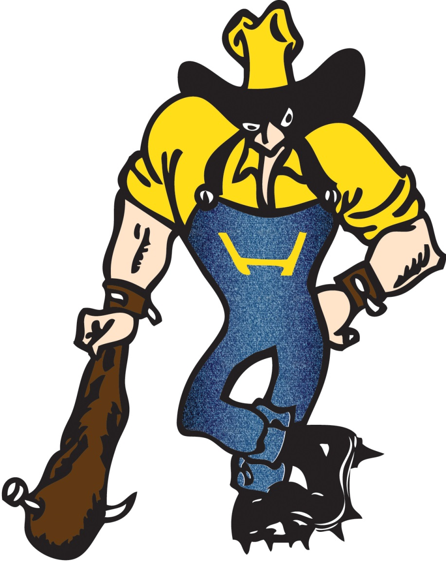
2015-16
Enrollment
Course Descriptions

Sixth Grade

6

Required Courses
Communication Arts
This course is designed to strengthen students writing and communicating abilities using strategies that are based on state standards and proven research. Students will be provided instruction in writing, spelling, and grammar, with parts of speech being a main focus in the grammar area. Writing will be centered on the writing process and the 6 + 1 writing traits model.

Math
6th grade Math This course is designed to take the basics learned at the elementary level and begin to apply these learned concepts in real world settings. The largest focus will be given to the strand, Number and Operations. The Number and Operations strand includes operations on whole numbers, fractions, and decimals. It also includes the order of operations and properties of numbers. Students will begin to gradually move from concrete mathematics to more abstract concepts. The basics of algebra are introduced in this course with a regard to variables and expressions. Data and probability, measurement, and geometric concepts will be covered as well. Students should find themselves equipped with adequate skills and preparation necessary to progress toward higher-level mathematics courses.

6th grade Accelerated Math This course is designed to cover the same major concepts as 6th grade Math, but will move at a faster pace and problem solving will be at a higher a level. A smooth transition into geometry and algebra is desired, and this course offers that opportunity through graduated exposure to these concepts. Students will develop the necessary tools to become confident problem solvers and should find themselves equipped with adequate skills and preparation necessary to progress toward Pre-Algebra.

Physical Education/Health
The Middle School Physical Education and Health class is designed to give students instruction on wellness and their overall well-being. Students will be participating in a variety of games and activities including units on football, soccer, volleyball, team handball, basketball, hockey, net activities, modern dance, tennis, and softball. In health, students will be exploring a variety of topics including personal hygiene, health, and wellness, safety, first aid/CPR, study habits, friendships, peer pressure, goal setting, and relationship building with parents.

Reading
The students will read various genres of text and practice reading comprehension strategies. They will also work with the elements of a story and characterizing components from text. While much of the reading in class will be required, students will also have the opportunity to explore the library and make personal selections. Students will be responsible for reading, writing, and producing projects related to reading material.

Science
Students will start to see the interaction of natural phenomena as being caused by certain energies, movements, and predictable changes. These changes are studied through body systems and disease, rocks and minerals, matter, ecology and scientific inquiry units with a tie-in to technology. Middle School Science supports the MAP test preparation by using formal terminology, answering questions with depth of knowledge of one, two and threes. Instructions are practiced with questions formatted to give familiarity to MAP testing. Note-booking is introduced so students will be better able to connect information to past experiences.

World History
This course is designed to increase the knowledge of civilizations of the past. Students study the ancient cradles of civilization: Mesopotamia, Egypt, India, and China. They explore the great European civilizations of Greece and Rome and life in Europe through the Middle Ages. The ancient Mesoamerican civilizations of the Mayas, Aztecs, and Incas are also studied. Students will use books, maps, and audio-visual media to enhance their knowledge. Students will add to their regular study guides with maps, map construction, research and reports. Class work will be done on both an individual basis and through cooperative learning groups.

Sixth Grade

6

Exploratory Courses
Art
This course is an exploratory class which extends for one quarter of the school year. The students will be exposed to a variety of art media, styles, and techniques incorporated in the making of art. Students will experience a brief study of art history and a variety of artists in an endeavor to gain an appreciation of visual art.

Computer Literacy
This course is an exploratory class which extends for one quarter of the school year. Using Microsoft Word, keyboarding concepts and times typing assessments. This course is designed to teach students how to demonstrate correct touch system techniques, develop and practice correct keyboarding techniques, key at a speed of 25-35 wpm with 80% accuracy and compose a variety of documents.

FACS
This course is an exploratory class which extends for one quarter of the school year. This is an introductory class that covers basic safety for students when home alone or babysitting. Students also study Foods & Nutrition, good eating habits and simple snack recipes. The other unit that is covered in this class is Clothing & Textiles, in which students do a simple sewing project and a craft project. A basic lab fee is required.

Health Enrichment
This class is an exploratory class which expands for one quarter of the school year. The Health Enrichment class is designed to give students instruction on making good choices. This class will discuss the dangers of drugs, alcohol, tobacco, and other health issues. The students will learn the effects that drugs, alcohol and tobacco can have on their futures and alternatives that they may choose instead.

Elective Courses
Intro to Band
Sixth grade band is designed to give students an opportunity to play a band instrument. Students will learn basic instrument techniques, music reading, music theory, music history, care and maintenance, and how to practice. The sixth grade band will perform at least two concerts throughout the year.
RISE
The RISE Gifted Education Program is a state-funded class for identified gifted students at Lafayette County C-1 Schools. Students who sign up for RISE need to be previously identified and accepted into the program. This year long course focuses on thinking skills, problem solving skills, creativity, and enrichment of common core Missouri Learning Standards through research and projects.
*this elective course will replace quarter exploratory courses (ART, Computer Literacy , FACS, & Health Enrichment)

Vocal Music
The student will learn the basics of individual and group singing. The student will also learn the basics of music theory, including note values, pitches on the staff, and music symbols. The 6th grade choir will perform 2-3 times throughout the year.

Academic Intervention
Study Assistance
Students may be assigned a study assistance course as an academic intervention. Students are provided time and assistance in completing assignments. Study skills, test taking, and behavior management strategies are taught. Enrichment activities and MAP Preparation are also provided.

Seventh Grade

7

Required Courses
Communication Arts
This course is designed to strengthen students writing and communicating abilities using strategies that are based on state standards and proven research. Students will be provided instruction in writing, spelling, and grammar, with parts of speech being a main focus in the grammar area. Writing will be centered on the writing process and the 6 + 1 writing traits model.
Geography
This course is designed to build on the background of geographical and cultural studies and the historical development of cultures presented in elementary school. Students look in-depth at North and South America. Students study earth movement and forms from globes; use maps and graphs to study geographic patterns; research information on major geographic regions; report orally and in writing the information interpreted through research and maps; construct maps; and assume responsibility for information received through group work and in-class activities.

Math
7th grade Math This course places an emphasis on operations with rational numbers, basic algebraic concepts, and geometric relationships and measurement. A smooth transition into geometry and algebra is desired, and this course offers that opportunity through graduated exposure to these concepts. Students who have developed the necessary tools to become confident problem solvers is the goal of the course. There are many opportunities for cooperative learning and hands on learning and best learning style application.

7th grade Pre-Algebra This course is designed to reinforce arithmetic concepts and help the student make the transition from arithmetic to algebra. Topics include: whole numbers, fractions, decimals, percents, ratio and proportion, measurement as well as graphic displays, equation writing and problem solving, and probability. Other subjects with limited emphasis are consumer topics such as simple interest, and discount and mark up, geometric shapes and their areas and volumes, similar shapes, congruence, basic trigonometric ratios, in addition to patterns, logic and symmetry and finally linear functions.

Physical Education/Health
The Middle School Physical Education and Health class is designed to give students instruction on wellness, and their overall well-being. Students will be participating in a variety of games and activities including units on football, soccer, volleyball, team handball, basketball, hockey, net activities, modern dance, tennis, and softball. In health, students will be exploring a variety of topics including healthy choices, healthy eating habits/nutrition, personal hygiene, eating disorders, physical fitness, communicable diseases, mental/emotional health, social health, relationships, conflict resolution, growth and development.

Reading
The students will read various genres of text and practice reading comprehension strategies. They will also work with the elements of a story and characterizing components from text. While much of the reading in class will be required, students will also have the opportunity to explore the library and make personal selections. Students will be responsible for reading, writing, and producing projects related to reading material.

Science
Students will use research and minds-on activities to investigate an organism’s characteristics and classification. The effect of technology, human activities, and weather on ecosystems will be examined on local and global levels. Concepts of chemical and physical characteristics and changes will be examined. Previously taught concepts will be reinforced through scientific inquiry. Middle School Science supports the MAP test preparation by using formal terminology, answering questions with depth of knowledge of one, two and threes. Instructions are practiced with questions formatted to give familiarity to MAP testing. Note-booking is introduced so students will be better able to connect information to past experiences.

Seventh Grade

7

Elective Courses
Art
The seventh grade art class is a semester long course designed to give the students an opportunity to study the visual arts. Students will experience the making of art using a variety of media and techniques in both two and three-dimensional art forms. Modern art and art throughout history will be explored in an endeavor to gain an appreciation of visual art.
Band 1
Seventh grade band is designed as a continuation of the skills and knowledge that began in sixth grade band. Students will learn intermediate instrument techniques, music reading, music theory, and music history. Performance opportunities may also include solo and ensemble contest and two concerts. Students will need to complete one of the following options in order to be eligible for Band 1: Intro to Band, summer band program (through summer school), summer lessons, and/or director’s approval.
Computer Literacy
This course is designed for students to improve keyboarding skills and work in Microsoft Word and Keyboarding Concepts. Keyboarding skill is focused on during the first half of the class and a variety of projects are worked on during the second half of the class period.
FACS
In this course, four units are covered. Foods & Nutrition is the study of nutrients and the foods that they are found in. Healthy eating habits are discussed and students learn to fix simple recipes. Clothing & Textiles is the study of fabric and fashion terms. Students learn how to use a pattern and complete a sewing project. Consumer Resources is an introduction into management of time, money and resources. Becoming an adult deals with the physical and psychological changes that are going on during puberty. A basic lab fee is required.
Graphics I
This is a semester long course for students with beginner to intermediate level keyboarding skills that are in the 7th or 8th grade, and that have completed a Computer Literacy course. Students will have the opportunity to experience projects from the textbook “Keyboarding Concepts” and teacher created projects using Microsoft Office programs in Word, Excel, Power Point, and Internet Explorer. Graphics I is a pre-requisite course to Graphics II.
Industrial Technology
This course is designed to introduce students to the basics of industrial technology. The course will involve several areas of basic study: precision measuring, weights and measures, tools ID and power tools operation, safety, and wood construction. Students may be required to provide some basic materials, but most materials will be acquired through the school. A basic lab fee is required.
RISE
The RISE Gifted Education Program is a state-funded class for identified gifted students at Lafayette County C-1 Schools. Students who sign up for RISE need to be previously identified and accepted into the program. This year long course focuses on thinking skills, problem solving skills, creativity, and enrichment of common core Missouri Learning Standards through research and projects.
Vocal Music
Middle school vocal classes stress the skills needed to advance to the high school choral program. Classroom goals include the improvement of individual vocal skills, auditory perception, and sight-reading. Students work together as a team. Students will learn the basics of music theory and sing different styles of music. Students will perform in one or two performances per semester.

Academic Intervention
Study Assistance
Students may be assigned a study assistance course as an academic intervention. Students are provided time and assistance in completing assignments. Study skills, test taking, and behavior management strategies are taught. Enrichment activities and MAP Preparation are also provided.

Eighth Grade

8

Required Courses
American History
This course encompasses the exploration and settlement of the United States from pre-historic times to 1865. The students will learn major causes and consequences of the American Revolution, territorial expansion, American democracy, Sectionalism, and the Civil War. The students will demonstrate knowledge of U.S. geography. Students will learn meanings of basic rights and liberties listed in the Constitution and will identify democratic ways of selecting leaders and primary democratic values of the U.S. Constitution.

Communication Arts
This course combines all components of communication arts into one class. In preparation for high school, students in this course will face a challenging curriculum. Using prior knowledge and newly acquired skills students will read, interpret, and analyze a variety of texts from multiple genres. In addition students will develop their grammar and spelling as well as compose and present a variety of writing pieces using the 6 + 1 writing traits model.

Math
8th grade Pre-Algebra This course is designed to reinforce arithmetic concepts and help the student make the transition from arithmetic to algebra. Topics include: whole numbers, fractions, decimals, percents, ratio and proportion, measurement as well as graphic displays, equation writing and problem solving, and probability. Other subjects with limited emphasis are consumer topics such as simple interest, and discount and mark up, geometric shapes and their areas and volumes, similar shapes, congruence, basic trigonometric ratios, in addition to patterns, logic and symmetry and finally linear functions.

8th grade Algebra This course is designed to prepare students for their high school and college mathematics work. Topics include but are not limited to: fundamental concepts of algebra, exponential notations, solving linear equations, linear applications, graphing linear equations, rates, slopes of lines, operations with polynomials, negative exponents, factoring, solving quadratic equations and quadratic functions, operations with rational expressions, solving rational equations, operations with radical expressions, trigonometric functions, quadratic formula, and systems of linear equations. Students develop some skills with graphing calculators, and are expected to gain basic knowledge of patterns, graphic displays, statistics and probability. At the end of the year, students will take the end of course exam for Algebra I.

Physical Education/Health
The Middle School Physical Education and Health class is designed to give students instruction on wellness, and their overall well-being. Students will be participating in a variety of games and activities including units on football, soccer, volleyball, team handball, basketball, hockey, net activities, modern dance, tennis, and softball. In health students will be exploring a variety of topics including healthy choices, healthy eating habits/nutrition, personal hygiene, eating disorders, physical fitness, communicable diseases, mental/emotional health, social health, relationships, conflict resolution, growth and development.

Physical Fitness/Health
The Middle School Fitness and Health class is designed to prepare students to improve their overall physical and mental health. During the fitness portion of class, the students will learn how to correctly perform a variety of Olympic style lifts and agility aspects through conditioning drills that they will perform daily. Some of the examples of lifts that will be performed will be: power clean, clean and jerk, jerk press, power snatch, squat, and military press. In health, students will be exploring a variety of topics including healthy choices, healthy eating habits/nutrition, personal hygiene, eating disorders, physical fitness, communicable diseases, mental/emotional health, social health, relationships, conflict resolution, growth and development.

Science
Students will expand on previously introduced earth science and physical science concepts thus strengthening the base for concepts to be built upon in high school. Using a variety of instructional methods, students will examine these concepts to gain a better understanding of the interrelationships of the earth, its spheres and the universe and the motion and energy transformations that occur due to forces. In addition, students will develop skills necessary to investigate problems using scientific inquiry. Middle School Science supports the MAP test preparation by using formal terminology, answering questions with depth of knowledge of one, two and threes. Instructions are practiced with questions formatted to give familiarity to MAP testing. Note-booking is introduced so students will be better able to connect information to past experiences.

8
Eighth Grade

Elective Courses
Art
The eighth grade art class is a semester long course designed to give the students an opportunity to study the visual arts. Students will experience the making of art using a variety of media and techniques in both two and three-dimensional art forms. Modern art and art throughout history will be explored in an endeavor to gain an appreciation of visual art.
Band 2
Eighth grade band stressed the skills needed to advance to the high school band program. Students will learn advanced instrument technique, music reading, music theory, music history, and basic marching skills and jazz techniques. Performance opportunities include the 8th grade marching band, solo and ensemble contest, and two concerts. Students will need to complete one of the following options in order to be eligible for Band 2: Band 1, summer band program (through summer school), summer lessons, and/or director’s approval.
Computer Literacy
This course is designed for students to improve keyboarding skills and seek information on the Internet. Keyboarding Concepts, a program consisting of lessons and speed tests to improve keyboarding skill, is used for 35-40 min/class and a variety of projects are worked on during the remaining class time. Projects include: Word, Internet, and a Vocabulary unit.
Exploratory Agriculture
This course is designed to introduce students to one of America’s most important industries – agriculture. Units of instruction will be selected from Introduction to Agriculture, Plan Science, Animals in Society, Products from Agriculture, Natural Resources and Conservation, Leadership and Personal Development, Home and Farmstead Safety, and Maintenance. A minor lab fee will be assessed to purchase lumber needed to construct basic wood projects during Home and Farmstead Safety and Maintenance Unit.
FACS
In this course, three units are covered. Foods & Nutrition focuses on meal/menu planning, food combinations and healthy eating choices. Students plan and prepare meals focusing not only on nutrition but also on time management. Clothing & Textiles introduces terminology used by the fashion industry. Students learn about fabrics and fibers, and their suitability for varying types of clothing. Students complete a simple sewing project. Housing & Interior Design is an introduction into the housing industry. Students learn how color, line, and space are used to create different environments, floor plans and room design. A basic lab fee is required.
Food Science
Instead of the science lab, this course uses the kitchen for various experiments with and about food. Students look at how ingredients and cooking methods affect the outcome of a product. Students complete a written analysis of experiment outcomes. There is a strong emphasis on math as well as collecting and recording data in this course.
Graphics I
A semester long course for students with beginner to intermediate level keyboarding skills that are in the 7th or 8th grade, and that have completed a Computer Literacy course. Students will have the opportunity to experience projects from the textbook “Keyboarding Concepts” and teacher created projects using Microsoft Office programs in Word, Excel, Power Point, and Internet Explorer. Graphics I is a pre-requisite course to Graphics II.
Graphics II
A semester long course for students with intermediate level keyboarding skills that are in the 8th grade and that have completed Graphics I course. Students will have the opportunity to experience advanced projects from the textbook “Keyboarding Concepts” and teacher created projects using Microsoft Office programs in Word, Excel, Power Point, and Internet Explorer.
Power and Construction
This course will include training and practice in woodworking, small gas engines, and basic home maintenance (electricity, plumbing, masonry). Shop Safety and Tool Identification skills will be enhanced. This course utilizes carpentry skills in the development and construction of a wood project. There will be a shop fee to cover the cost of materials. Prerequisite: Pass Intro to Technology

Eighth Grade

8
Elective Courses

RISE
The RISE Gifted Education Program is a state-funded class for identified gifted students at Lafayette County C-1 Schools. Students who sign up for RISE need to be previously identified and accepted into the program. This year long course focuses on thinking skills, problem solving skills, creativity, and enrichment of common core Missouri Learning Standards through research and projects.
Vocal Music
Middle school vocal classes stress the skills needed to advance to the high school choral program. Classroom goals include the improvement of individual vocal skills, auditory perception, and sight-reading. Students work together as a team. Students will learn the basics of music theory and sing different styles of music. Students will perform in one or two performances per semester. The RISE Gifted Education Program is a state-funded class for identified gifted students at Lafayette County C-1 Schools. Students who sign up for RISE need to be previously identified and accepted into the program. This year long course focuses on thinking skills, problem solving skills, creativity, and enrichment of common core Missouri Learning Standards through research and projects.

Study Assistance
Students may be assigned a study assistance course as an academic intervention. Students are provided time and assistance in completing assignments. Study skills, test taking, and behavior management strategies are taught. Enrichment activities and MAP Preparation are also provided.
Reading
This course is designed to help students reading two or more grade levels below district and/or state criteria: Students will be provided intense reading and writing instruction based on individual and class need. Course content will be presented in a specific sequence with each unit’s concepts building upon the previous unit. Placement will be determined through district and/or state assessment results as well as teacher and administrative recommendations.

Academic Intervention

